|  |  |  |
| --- | --- | --- |
|  |  | YWY  Pet Store |

Phone：509-964-6700

Email：876283486@qq.com

CWU

400 E. University Way

Ellensburg, WA 98926

Contents

Introduction 4

Presentation 5

Cover letter 6

Business concept 8

Brochure 12

Market Research document 13

Financials section 22

Introduction to Financials 22

Budget intro with link to latest Budget Template and Price Trends workbooks 22

Price Comparison Database intro with link to latest PCDB 22

Summary of Financials 22

Appendix 23

Resume 23

Privacy and Ethics paper 24

Figure 1 14

Figure 2 15

Figure 3 17

Figure 4 18

Figure 5 19

Figure 6 20

Figure 7 20

Figure 8 21

**Introduction**

*Pets are always the way to give people happiness.* However, many people don’t always have a chance to raise them. For example, students who live in dorm will prohibited to take animals home except emotional support animals, because it will disturb others or cause some hygiene issue. Besides, there is a kind of people who love animals but have a disability to be close to animals. For instance, allergy. So how can they get their own pets? A new kind of pet’s store will change the selling way and pay more attention to take care of pets.

**Presentation**

Link: [ppt](\\\\NEVE\\cs101005_66$\\LAB11.pptx)

The presentation shows a new kind of business . YWY is the store which can help you take care of everything about your pets.

**Cover letter**

**Yiwei Wu**

1301 N Chestnut St

Phone：509-964-6708 Email：928346586@qq.com

January 25，2017

CWU

400 E. University Way

Ellensburg, WA 98926

Dear Hiring Manager，

I am writing to inquire about possible opening new pet store for the assistant. I am interested in this job which offering the opportunity to be close to lovely pets.

As a CWU student, I am eager to have a chance to work in this new type of pet’s store. Given my background, I think I have enough ability to achieve this job. I know many basic computer skills and I have the experience of working. Besides, I am familiar with animals.

Please read my resume. Feel free to call me at 509-964-6708, to arrange a time to meet. I look forward to hearing from you.

Sincerely,

Yiwei Wu

Enclosures: Resume

**Business concept**

What are the advantages of a new type of pet store?

* Release risks
* Ethical

[Ryan Lytle](http://www.usnews.com/education/best-colleges/articles/2011/05/19/bring-your-pet-to-college)[1]，a

Ryan Lytle, 8

，claims that pets are the way to ease the transition to college life. Nevertheless, sometimes pets will cause some risks and unnecessary expenses. For instance, Megan Goldner, an interviewee in Lytle’s article points that her cat wreaked havoc on the carpet which worth hundreds of dollars in her rent house. So, one of the most difference things for this new kind of pet’s store is that, they don’t sell animals. In fact, they support pet’s accommodation and sell different plans.

This store is work for students, someone can choose any kind of pets he or she like in store. He or she can let his or her pets live in store and feed them. He or she can do everything with his or her own pets like feeding, washing and playing in stores. As many students cannot balance the attention between pets and study. Sometimes they ignore meeting pets’ emotional and physical needs. If students buy a cat or dog but always let them stay at home, it isn’t a ethical behavior. Stuart Spencer[2], the author of Journal Agricultural and Environmental Ethics, claims that owner shouldn’t give pets an unusual natural environment. [3]Melanie J. Rock, a writer of health promotion international, said that pets need someone to play with

them. For example, walking. It will cause positive effect for dogs ‘emotion. When students need to prepare for their exams or papers, staff will help them to take care of pets.

Stores will offer a lot of services, like pets grooming, training, playing and so on. Since the pet don’t leave the store, the medical care of them will be easier and more completely. Owners cannot always realize their pets ‘health condition at home. In contrast, stores will invite doctors once or twice a month to check them. Dr. rich, a veterinary who works in PetSmart, mentioned in Journal of Avian Medicine and Surgery[4] that many individual pet shops usually lack health awareness and only focus on critical or acute trauma cases.

This new pets store adapt installment. Customers will choose which level of plans and pay them monthly. It depends on how much money they want to spend and how many services they want to give to their pets. However, there are still many students don’t have enough money to adopt a dog. Stores will offer another option for them, they can share the owner’s right to another one like friends or lover. In that case, it can release consumers ‘cost but not stores ‘profit. And it will be a good way to produce wonderful memory. Secondly,

when they have some other reason and must leave, such as transfer, graduate or others. They can give up the right of pets, and stores will help them to find another owner. This way can help to release the number of homeless animals. And the new owner doesn’t need to be worried about if their pets have some health problems.

Finally, for students who are interested in pets’ care and looking for a job, new pets store is a good choice to improve their responsibility. Since pets will still stay in stores after they are sold, the new pet store will need more employers than others.

**[Brochure](\\\\NEVE\\cs101005_66$\\LAB8.pdf)**

**Market research document**

## Market Research

-The pet store

“Selling More Gifts for People and Pets at Pet Stores”

This article shows a new kind of way to sell more products. The pet store owner choose to give people and pets some gifts. When they decide the price, they will let the price include the cost of gifts. Since this article was published in New Year, it focus on encouraging people to buy one product as a gift for their small puppies or cats. In addition, paying more attention to the quality of toys, clothes and food will be helpful to the sales volume. I think this idea is especially good for the pet store I design. Young people always like to design something and focus on the quality and appearance. Giving them more opportunities to dress up their pets will be attractive.

Danielle Chockley said that：“

“Selling More Gifts for People and Pets at Pet Stores”, 13

Ryan Lytle, 8

.”[5]

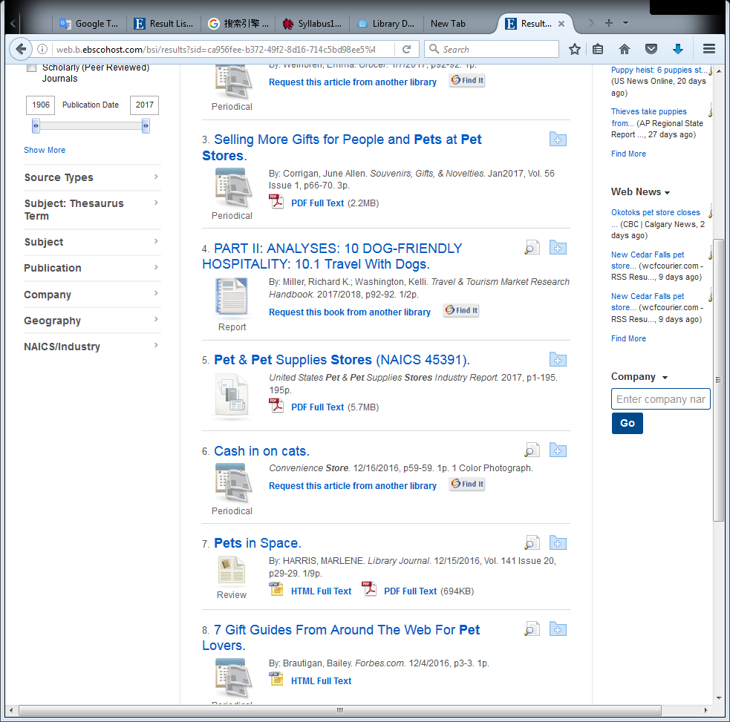

Figure

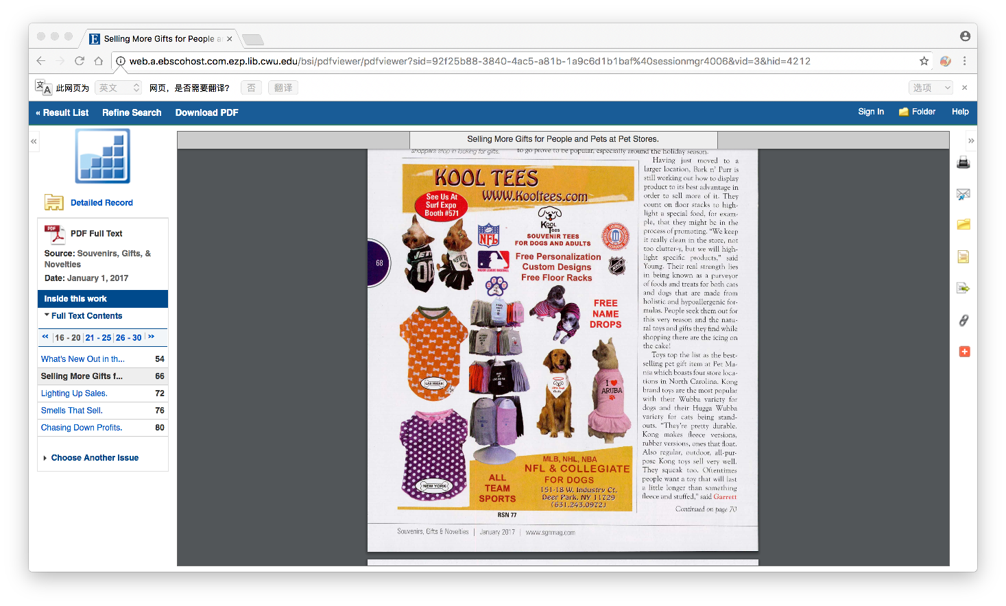

Figure

[6]

### New ideas

Per the lab, I found that I cannot Ignore another group. I just think about the student when I design my pet store. However, the market research shows that the middle age and old people are a huge group which prefer pets. I need to focus on the way to attract different ages.

“Businesses go to the dogs: While one PetsMart Inc. opens two new superstores, nine other area pet stores fight bankruptcy. Michael Lewis reports.”

This article is about the situation of the small pet store in the market. It shows that the individual small pet store is possible to fight with the big pet market. Although big pet market might have more spaces and options, small individual stores have their own customers and special places. A large market sometimes close sooner than small one. Besides, the research shows that Having pets becomes more and more common in the USA. In conclusion, this is also a good proof to show that opening a small but special pet store is a good idea. This business idea has profit.

Pet supply "

“Businesses go to the dogs: While one PetsMart Inc. opens two new superstores, nine other area pet stores fight bankruptcy. Michael Lewis reports.”, 16

“Selling More Gifts for People and Pets at Pet Stores”, 13

Ryan Lytle, 8

," he said.[7]

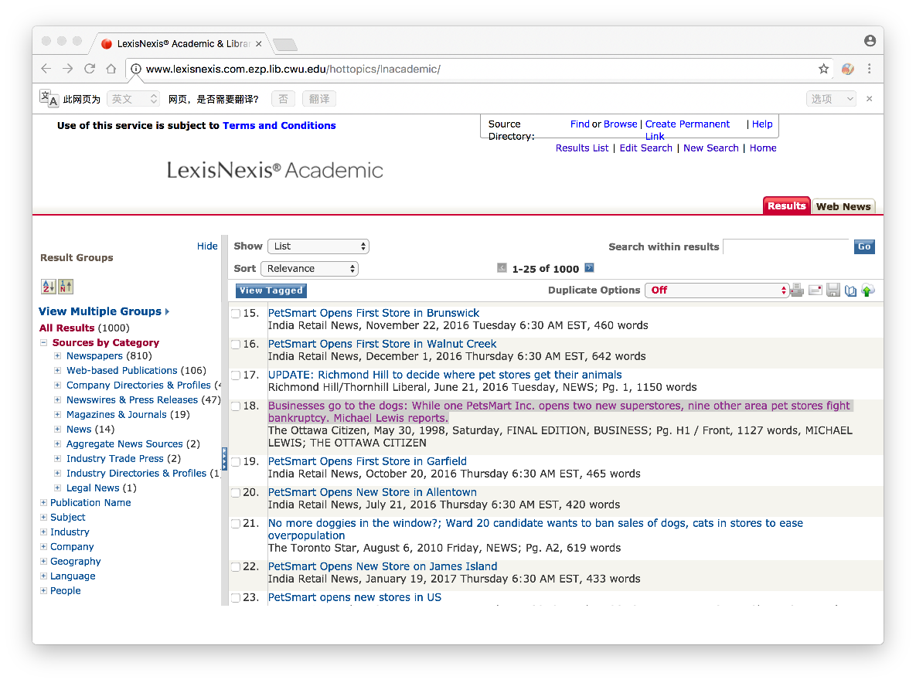

Figure

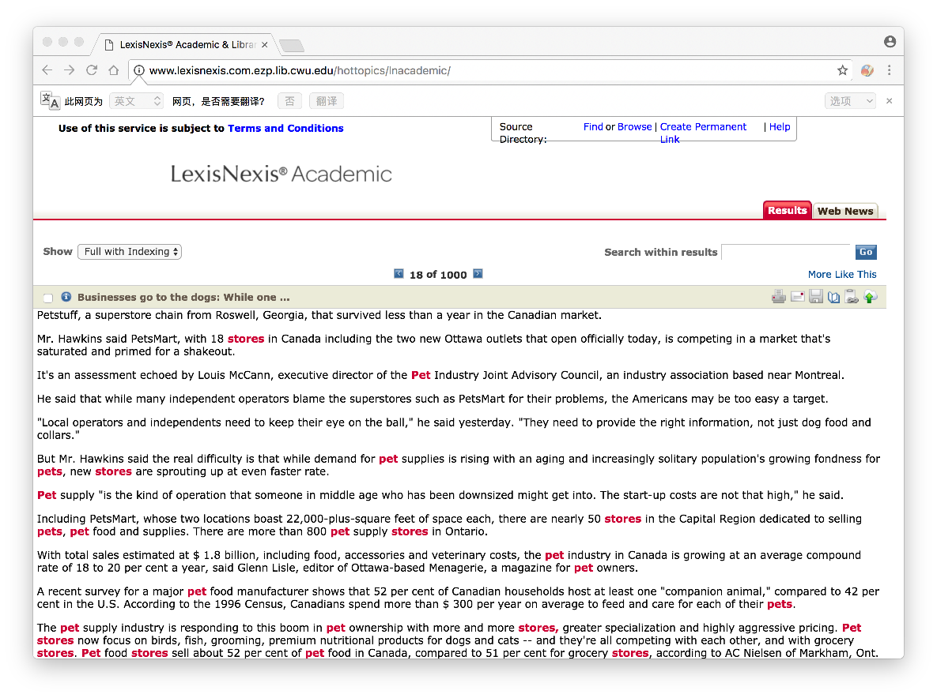

Figure

[8]

“Veterinary diet pricing: Competing with the pet food store”

The author indicates that veterinary usually ignore telling owner about the choosing of pet food, because they think the owner will think the diet they recommend is expensive and the veterinary don’t want to look like crazy salespeople. In fact, the diet which veterinary recommend is often cheaper and healthier than the diet which pet store choose. This article help me to prove that the advantage of connecting with the veterinary. Since I want to have a pet store which include the veterinary service, it will make owner feel relieved. They don’t need to be confused about choosing which diet. The new pet store will adapt the veterinary’s idea. Thus, pets will get better care.

“

“Businesses go to the dogs: While one PetsMart Inc. opens two new superstores, nine other area pet stores fight bankruptcy. Michael Lewis reports.”, 16

“Selling More Gifts for People and Pets at Pet Stores”, 13

Ryan Lytle, 8

Veterinary diet pricing: Competing with the pet food store, 18

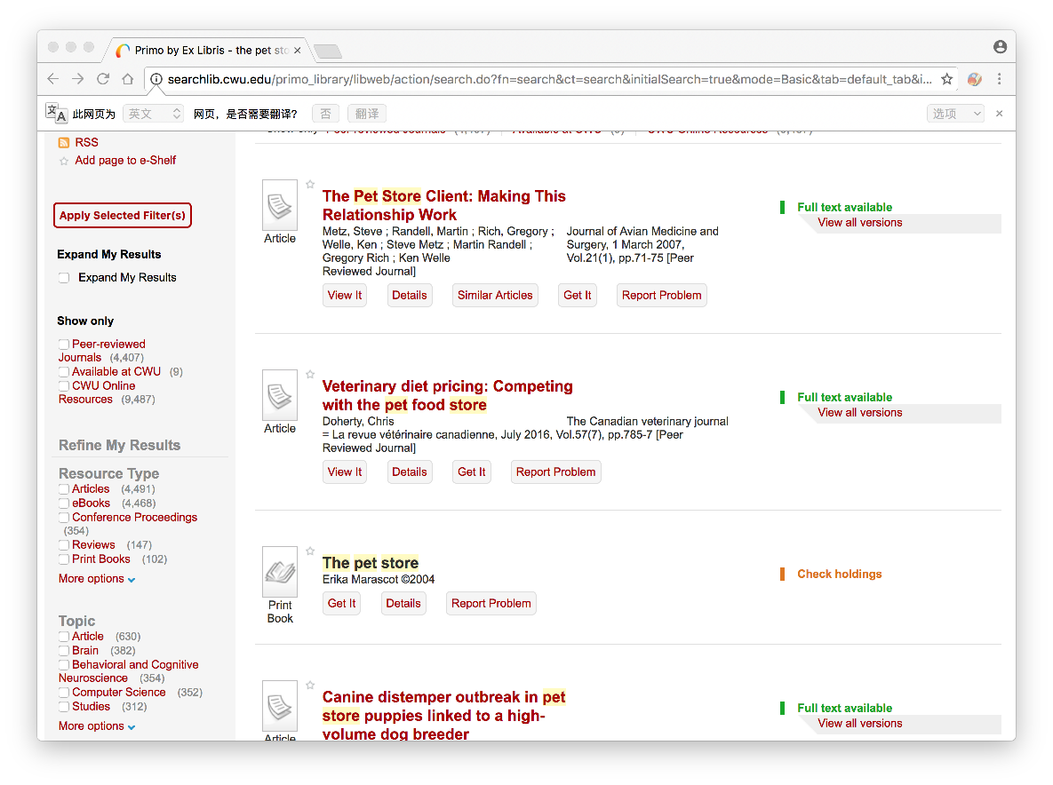

Figure

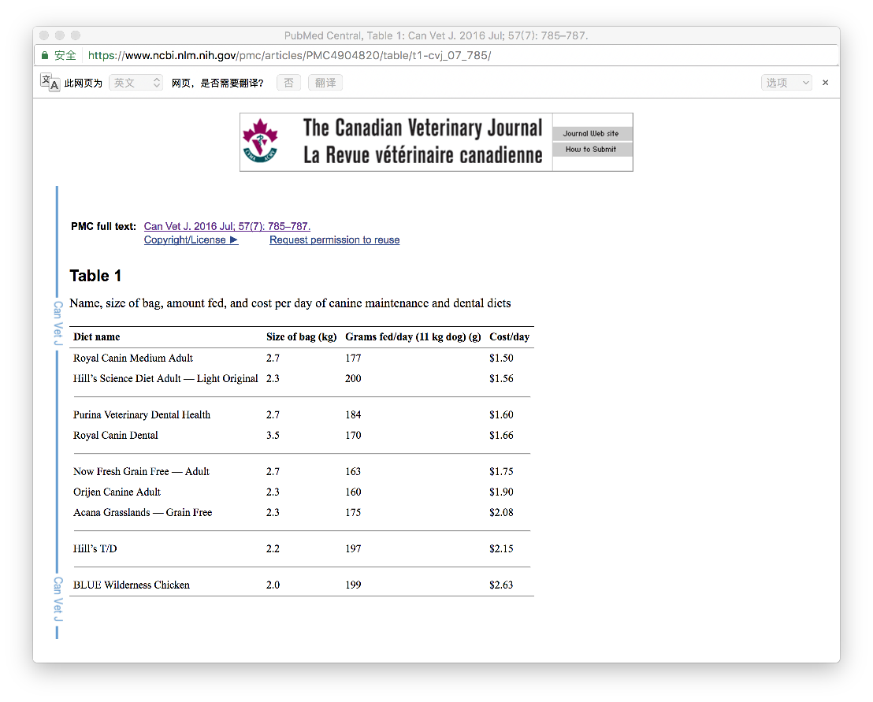

Figure

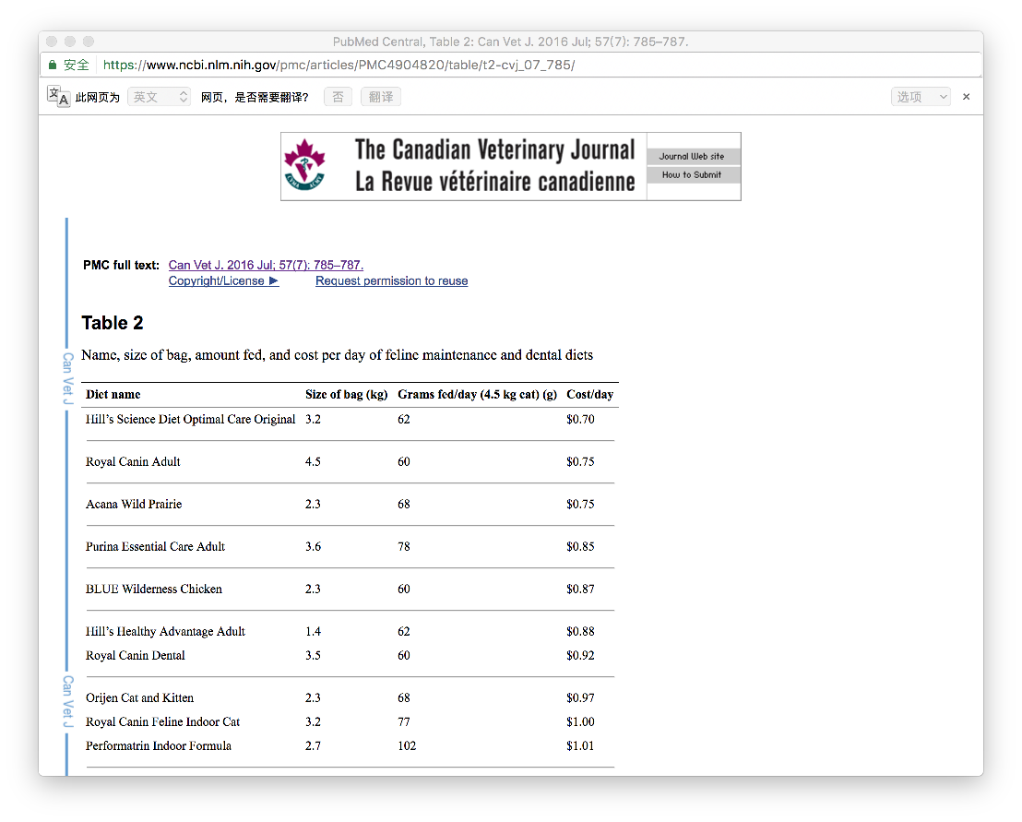

Figure

[9]

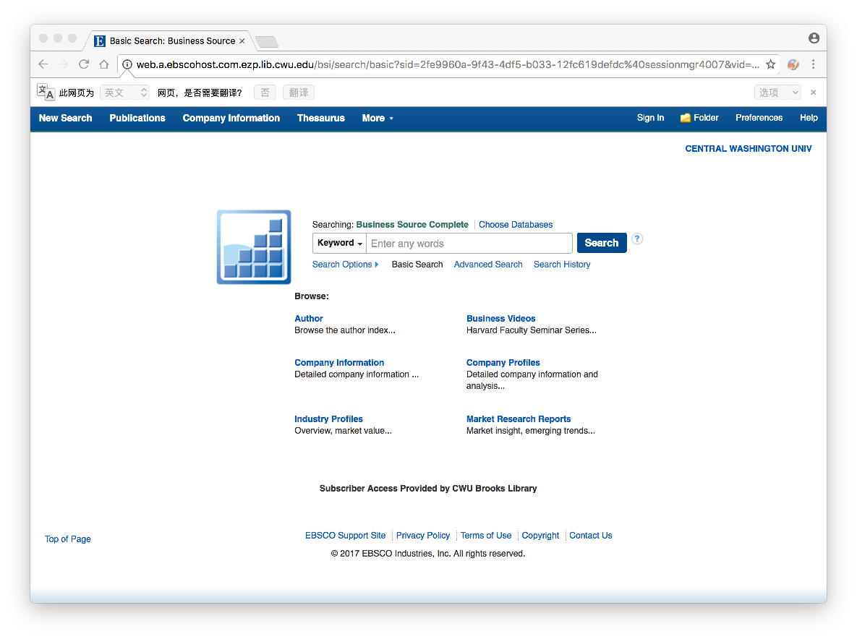

Figure

**Financial section**

* **Introduction to Financials**

**The financials of pet store has a lot of complicated elements. People need to think about both its cost and its deposits.**

* **Budget intro with link to latest Budget Template and Price Trends workbooks**

**The budget shows the balance of the costs (food, equipments, medical fee and so on) and the deposit.**

**[budget](\\\\NEVE\\cs101005_66$\\lab12.xlsx)**

**[Price Trends Workbooks](\\\\NEVE\\cs101005_66$\\Lab15.xlsx)**

* **[Price Comparison Database](\\\\NEVE\\cs101005_66$\\15.accdb)**
* **Summary of Financials**

It shows that the new pet store idea is an idea which can be successful and meaningful.

**Appendix**

Resume

|  |
| --- |
| *Name: YIWEI WU* |
| Qualification Summary: 3 years of experience on taking care of pets. Excellent for understanding customer’s requirement. |
| Technical Skills: bilingual (Chinese and English), computer skills |
| Experience:   * Having two dogs at home (completely taking care of them by myself) * Do pet-related charity activities * Do some translation work |
| Education: undergraduate student |
| Dates:1/2017 |
| Contact information: phone: 5099646708  Email: [928346586@qq.com](mailto:928346586@qq.com) |

**Privacy and Ethics paper**

Recently, the status of Internet becomes more and more important. More and more people store their private information on the Internet. Then, the privacy and ethics problem appears. “The Internet clearly is a very powerful research tool, and its benefits--such as the ability to reach large numbers of people, at very low cost--are alluring. But like all powerful tools, it can be destructive if it is not used properly, or if it falls into the wrong hands.” The government and suppliers also decide to create some new policy about the Internet.

Cruz then backed it up with this op-ed in The Washington Post, arguing, "Government-regulated utilities invariably destroy innovation and freedom. ... If the federal government seizes the power to regulate Internet pricing and goods and services, the regulations will never end." The Net Neutrality always a large topic for people who would like to discuss.The government should treat all customers equally. Otherwise people's freedom and interests are not guaranteed.

“Can tweets be analyzed to predict heart disease? New research suggests the answer is yes.” Now, some people choose to observe tweets to make sure the mode of diseases. “In fact, anger, hostility and aggression on Twitter is better able to predict patterns of heart disease than 10 other leading health indicators, including smoking, obesity and hypertension.” Actually, this is a kind of a new way to help medical service. However, the privacy problem also important. Is it ok to decide if someone have diseases from their comments on the Internet? The method may be effective, but the person to be tested will not be happy with it and will be considered a violation of privacy.

Moreover, protecting privacy sometimes conflicts government orders. Criminals will use the Internet, their information is also a privacy. What should the supplier do when the government needs information on criminals? Once provided information that means disclosure of the customer, this will result in a loss to the customer. However, if they refuse to help, the supplier is equivalent to help criminals escape, that will cause greater harm to society. “After Syed Rizwan Farook and his wife killed 14 people in December, the government publicly sought a court order to compel Apple to unlock Farook's work phone. Apple opposed that order, heightening long-standing tensions between Silicon Valley and law enforcement.” That’s the example of privacy problem. Apple wants to know how the government *get* the information from the internet, because they want to fix the vulnerability. Nevertheless, the government reject Apple’s request.

In conclusion, the ethic and privacy problems are still hard to solve. About the net neutrality, people have different opinions. The development of technology makes privacy and ethics destroyed. Even if the starting point is good, sometimes it is difficult to be accepted by people.

Work Cited

<http://eds.b.ebscohost.com.ezp.lib.cwu.edu/ehost/detail/detail?sid=e730fe01-0e5d-4e7c-8284-87eb5dea60cc%40sessionmgr102&vid=2&hid=114&bdata=JnNpdGU9ZWhvc3QtbGl2ZQ%3d%3d#AN=2608170&db=a9h>

<http://www.npr.org/sections/alltechconsidered/2014/11/14/364059910/tech-week-that-was-obama-rocks-the-net-neutrality-debate>

<http://www.npr.org/2015/02/24/388665887/angry-tweets-predict-patterns-of-heart-disease-researchers-say>

<http://www.latimes.com/business/technology/la-fi-tn-apple-next-steps-20160330-story.html>

1. Ryan Lytle, "Bring Your Pet to College | Best Colleges | US News." N.p., 19 May 2011. Web. 13 Jan. 2017.
2. Spencer, S., Decuypere, E., Aerts, S. et al. J Agric Environ Ethics (2006) 19: 17. doi:10.1007/s10806-005-4379-8
3. Melanie J. Rock, Health Promot. Int. (2015) 30 (4): 976-986. doi: 10.1093/heapro/dau017

   First published online: April 2, 2014
4. Steve Metz, Martin Randell, Gregory Rich and Ken Welle, Journal of Avian Medicine and Surgery, Vol. 21, No. 1 (MARCH 2007), pp. 71-75
5. Corrigan, June Allen. "Selling More Gifts for People and Pets at Pet Stores." Souvenirs, Gifts, & Novelties 56.1 (2017): 66-70. Business Source Complete. Web. 23 Jan. 2017.
6. <http://web.a.ebscohost.com.ezp.lib.cwu.edu/bsi/pdfviewer/pdfviewer?sid=92f25b88-3840-4ac5-a81b-1a9c6d1b1baf%40sessionmgr4006&vid=3&hid=4212> Jan 23, 2017
7. Michael Lewis, “Businesses go to the dogs: While one PetSmart Inc. opens two new superstores, nine other area pet stores fight bankruptcy. “May 30, 1998, Saturday, FINAL EDITION. Web. 23 Jan. 2017
8. <http://www.lexisnexis.com.ezp.lib.cwu.edu/hottopics/lnacademic/> Jan 23, 2017
9. <https://www.ncbi.nlm.nih.gov/pmc/articles/PMC4904820/> Jan 23, 2017